From Backdrop to Subject, Atlanta in Modern Media

By Lorelei Whitlow & Giana Danzilo | April 21, 2026

Atlanta has been deemed the “Hollywood of the South” for over a decade now, and for good reason. In 2008, Georgia passed a film tax incentive program, which offered studios up to 30% tax credits on their production costs, making it a lot cheaper for studios to film in Georgia as compared to locations like California and New York, two major film hubs. Thus, Atlanta, Georgia’s capital, became increasingly involved and represented as part of the film industry. However, studios weren't coming to Atlanta because they wanted to tell its story. For the most part, studios flocked to the city for the tax breaks, while Atlanta often became a backdrop–not a subject.
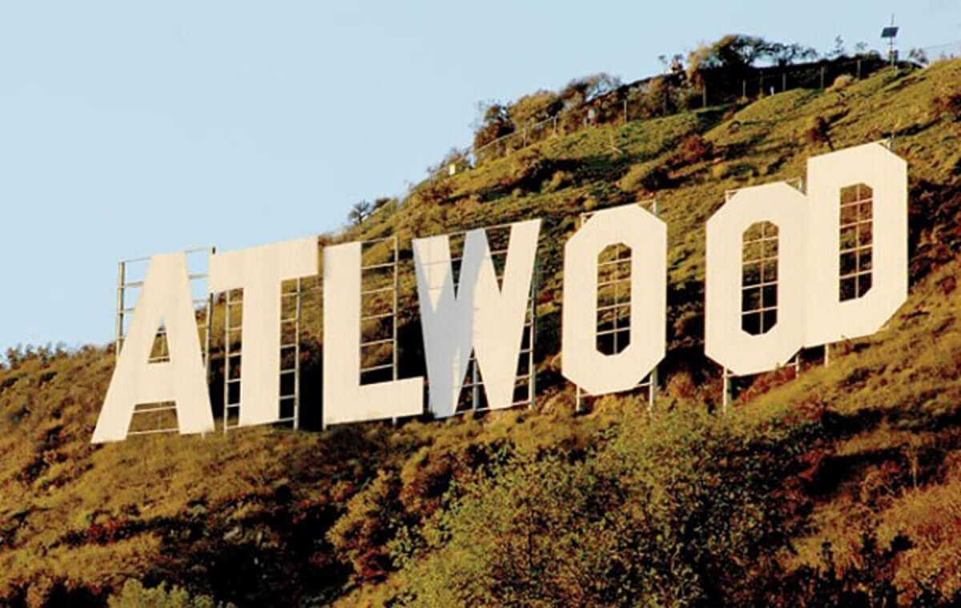
A digitally edited Hollywood sign representing Atlanta becoming a new film hub (Nowlin)

In 2022, Atlanta had the resources to spend about $4.4 billion on film and TV production. Still, apart from economics, Atlanta represents perks as a filming and production location. In terms of its location, Atlanta offers heavily forested areas and nature preserves in addition to metropolitan views, including an exceptional city skyline. Also, as the host of the busiest international airport in the world, Atlanta, as a creative destination, is able to provide transportation and thus access to creatives all over the world.
Atlanta hosts strong arts and creative culture, filled with and covered by art, including countless murals throughout its streets. Additionally, Georgia includes SCAD (and the SCAD film festival), Georgia State University, University of Georgia, and Emory
University–all institutions which offer film educations. Atlanta, Georgia holds the Atlanta Film Festival, which is one of the largest and longest running film festivals in the United
States, and its production infrastructure includes major studios like Tyler Perry Studios, Trilith Studios, and Shadowbox Studios as well as sound stages and other production-based facilities.
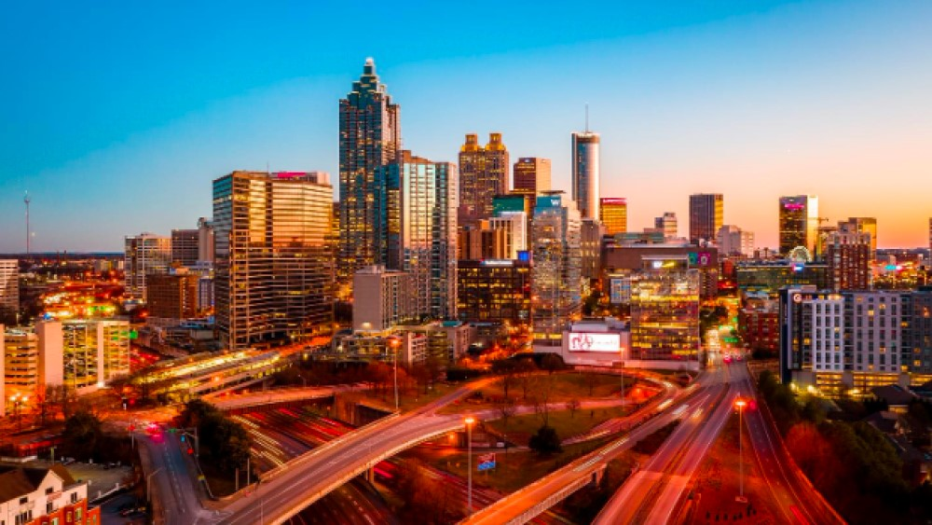
Atlanta’s iconic skyline during sunset hours (Bolen)

More diversity and representation of marginalized people is embedded in Atlanta’s creative media, which is particularly significant within a persistently white-dominated film industry. Strong black creative presence, including studios and creators like Tyler Perry and Tyler Perry Studios, as previously mentioned, offer local hiring opportunities, inherently drawing more diversity into media because of the city's nearly half black population. Furthermore, Atlanta has contributed to regional storytelling and perspectives, like Donald Glover’s TV show Atlanta, offering underrepresented narratives and uniquely calling attention to Atlanta as more than just a backdrop.
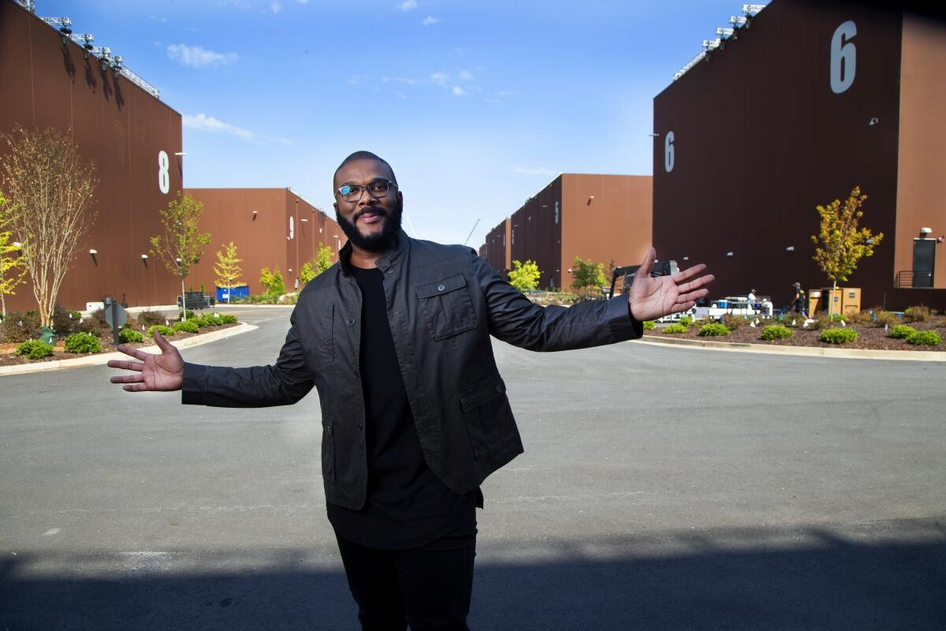
Tyler Perry pictured in front of his own Tyler Perry Studios! (Braxton)

All that said, Atlanta, Georgia is a unique setting, yielding remarkable filming and production opportunities, resources, and experiences.
With specific regard to Atlanta’s film success, several large-scale, commercial productions that Atlanta has hosted include Baby Driver, Hunger Games, and several marvel films: Black Panther, Avengers: Infinity War, and Ant-Man and the Wasp.
Among Atlanta’s media productions are the television shows, The Walking Dead and Stranger Things. These shows are globally recognized and chose Atlanta in which to be produced because of the incentives discussed, particularly Atlanta’s financial advantages, variety of film locations, and established production infrastructure.
Themes of these shows support a positive image of Atlanta–even if serendipitously. These themes include a strong sense of community and resilience, as The Walking Dead emphasizes survival through cooperation and rebuilding society, reflecting Atlanta, Georgia as a place of endurance and adaptability. Additionally, Stranger Things highlights tight-knit communities, local friendships, and everyday life, and even though set in Indiana, filmed environments in Georgia evoke warmth and familiarity.
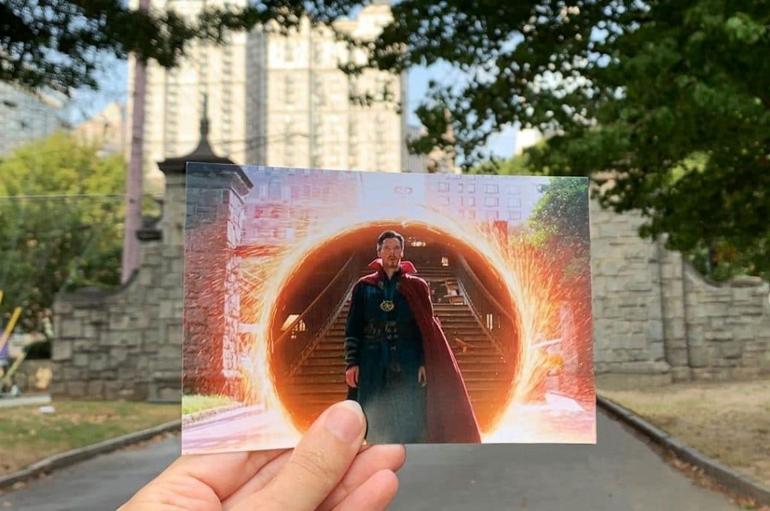
Dr. Strange filmed in Piedmont Park, although it was set in NYC (Rattenbury)

Both The Walking Dead and Stranger Things prominently feature forests, open land, and rural landscapes, presenting Georgia as visually rich and diverse, and the global success of both series positions Atlanta as a creative and cultural hub which ultimately reinforces its nickname as a rising entertainment capital.
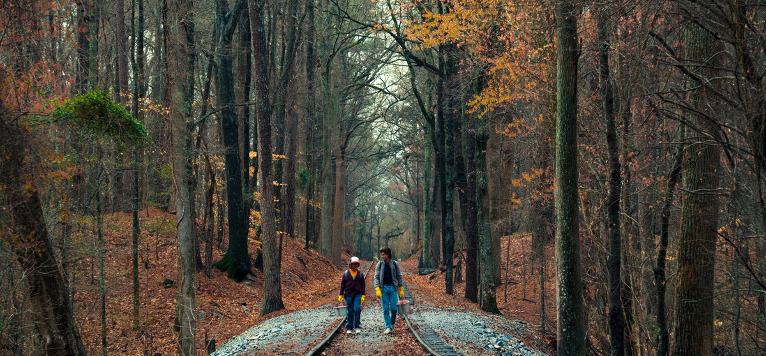
Stranger Things being filmed in Stone Mountain Park (Walljasper)

Atlanta is most definitely deserving of its title as “the Hollywood of the South,” but even more so, Atlanta represents a unique city with unique opportunities and advantages that establish it as a third film hub as opposed to just an iteration of the already established “Hollywood” of California.
However, since the Covid-19 pandemic, Atlanta, as well as the film industry more generally, has struggled, experiencing a shift in production largely because of the global shutdown and increased streaming. Furthermore, in this new and uncertain age of artificial intelligence, which sparked many of the writers’ strikes of 2023, the industry has become even more destabilized.
After peaking its film production in 2022, Atlanta film and TV production spending as well as the number of total productions dropped by nearly half: $4.4 billion to $2.3 billion and 412 production to 245 productions. Production is moving abroad–particularly to the UK–because of lower filming costs.
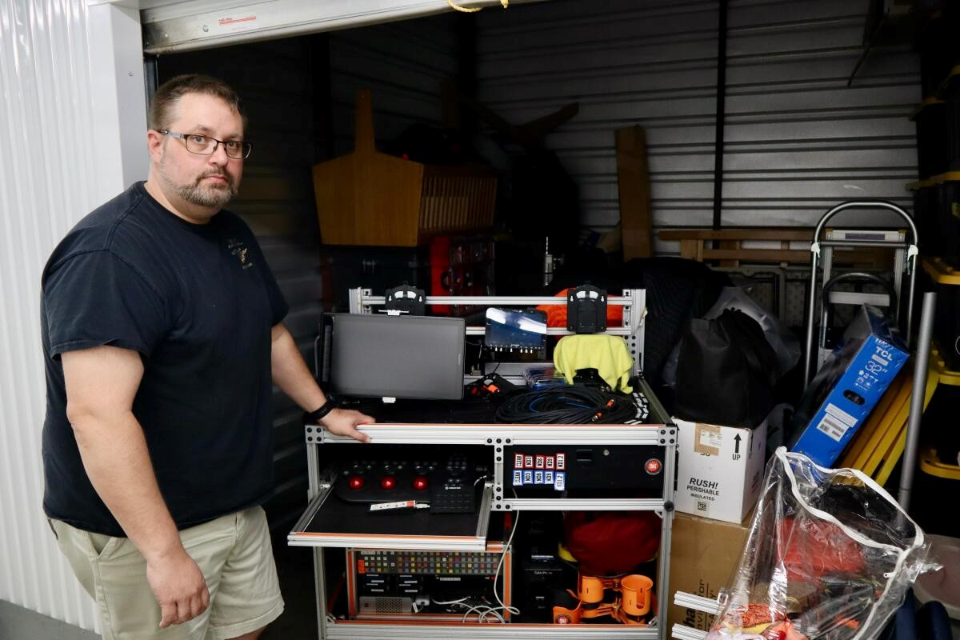
Digital producer standing next to his unused equipment held in a storage unit (Rico)

Nevertheless, Atlanta remains an artistic hub and significant contributor to the film industry, represented in popular media. It is worth noting Atlanta’s unique grounds for local and independent art scenes (e.g. High Museum of Art), public art and community-based work (e.g. street art and murals), music as the global capital of hip hop and R&B, and festivals and immersive experiences (e.g. Shaky Knees Fest) that no doubt influence its overall creative appeal.

References

Bolen, Brook. "Great Escapes: Our Guide to Atlanta, GA." AVL Today, 29 Nov. 2022, avltoday.6amcity.com/great-escapes-our-guide-to-atlanta-ga.
Braxton, Greg. "Tyler Perry Studios Atlanta Dedication." Los Angeles Times, 2 Oct.
2019, www.latimes.com/entertainment-arts/tv/story/2019-10-02/tyler-perry-studios-atlanta-dedi cation.
Nowlin, Jordan. "Piecing Together Georgia's Post-Production Tax Break." ECG Productions, 17 Feb. 2021, www.ecgprod.com/georgia-post-production-tax-break/.
Rattenbury, Jack. "5 Marvelous Filming Locations in Atlanta for Superhero Lovers." Secret Atlanta, 9 May 2022, secretatlanta.co/marvel-filming-locations-atlanta/.

Rico, R.J. "Is Atlanta Still the Hollywood of the South?" Los Angeles Times, 12 Mar.
2026, www.latimes.com/business/story/2026-03-12/is-atlanta-still-hollywood-of-south.

Walljasper, Matt. "A Map of All the Places Stranger Things Has Filmed near Metro Atlanta." Atlanta Magazine, 4 July 2019, www.atlantamagazine.com/news-culture-articles/a-map-of-all-the-places-stranger-things -has-filmed-near-metro-atlanta/.

Dockterman, Eliana. “How Georgia Became the Hollywood of the South: TIME Goes behind the Scenes.” TIME, Time, 26 July 2018, time.com/5348962/hollywood-in-georgia/.

“Is Atlanta Still the “Hollywood of the South”? Local Film Industry Faces Dropping Production Numbers.” Cbsnews.com, 12 Mar. 2026, www.cbsnews.com/atlanta/news/is-atlanta-still-the-hollywood-of-the-south-a-film-boomt own-faces-a-test/.

